Grade 7 Accelerated · Unit 3 · Lesson 8  Writing Large Numbers in Scientific Notation  Question Bank 3.08 ANSWER KEY | Name  Date  Period

Show your work. Circle your final answer.
For questions 1 through 4, write each number in scientific notation.
1. 9,000


2. 4,500,000


3. 310,000,000


4. 7,020,000,000

The zero between the 7 and the 2 stays in the coefficient.

For questions 5 and 6, write each number in standard form.
5. 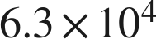
63,000

6. 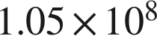
105,000,000

Real quantities.
7. Write each quantity in scientific notation.
a. There are about 1,670,000,000,000,000,000,000 molecules in a drop of water.
 molecules
b. The average distance from Earth to the Sun is about 93,000,000 miles.
 miles
c. A computer displays the number of stars in a galaxy as 4E11. Write it in standard form.
400,000,000,000
E11 means × 10¹¹.

8. Complete each comparison.
a. How many times larger is 8.1 than 5.4?
1.5
b. How many times larger is  than ?
10
c. How many times larger is 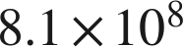 than 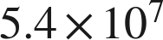?
1.5 × 10 = 15 times larger

9. Answer each question.
a. A blue whale weighs about 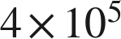 pounds. An elephant weighs about  pounds. How many times heavier is the blue whale?
40 times
4 ÷ 1 = 4 and 10⁵ ÷ 10⁴ = 10.
b. Florida has an area of about 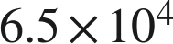 square miles. Lake Okeechobee has an area of about 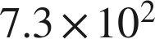 square miles. About how many times larger is Florida? Round to the nearest whole number.
about 89 times
6.5 ÷ 7.3 ≈ 0.89 and 10⁴ ÷ 10² = 100; 0.89 × 100 ≈ 89. Directly: 65,000 ÷ 730 ≈ 89.04.

10. Which of the following is greater? Explain how you know.
a. 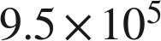 or 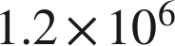
 — 10⁶ is greater than 10⁵, so the powers decide; 1,200,000 > 950,000.
b. 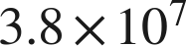 or 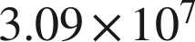
 — same power, so compare coefficients: 3.8 > 3.09.

11. Which is 52,000,000 written in scientific notation?
● A. 
○ B. 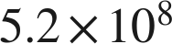
○ C. 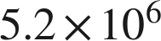
○ D. 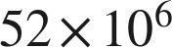
A

12. Select ALL of the expressions that are equal in value to 3,400,000.
☐ A. 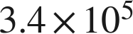
☒ B. 
☒ C. 
☒ D. 
☒ E. 
☐ F. 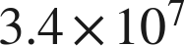
B, C, D and E
Only D is in scientific notation; B, C and E are equal in value but their coefficients are not in [1, 10).

13. In question 12, only one of the four equal expressions is written in scientific notation. Which one is it, and why are the other three not?
. In scientific notation the coefficient must be at least 1 and less than 10; 34, 340 and 0.34 are not.

